Car value mini-unit

Discussion: what determines car value, how figured, options available, etc

Demonstrate features of JDPower, Kelley Blue Book, and Edmunds Web sites

Explore Web sites and create table to compare values:

Vehicle | Features | JDPower | KBB | Edmunds
2012 Hyundai Sonata | 66,000 miles, front & rear heated leather seats, hybrid | Average Price Paid: $8,925  Average Condition: $6,250 | Private Party: $7,546  Trade-in: $5,319 | 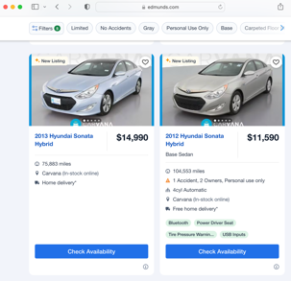
High school
Dream or future

compare and contrast sites, explain the differences in pricing, affects of options in pricing

Explore car sites: screen shot of one you see yourself purchasing in the next two to three years (or current vehicle) and one of your dream vehicle (or future vehicle)

Evaluation: write reflective paragraph on what you learned, likes, dislikes, changes to improve mini-unit, general comments

Next mini-unit: using your vehicle choices from this mini-unit to calculate interest payments using interest calculators and explore buying options and the cost of interest; expand to housing

